

Worksheet: - 2.1

# Student Name: Sahil Kaundal UID: 21BCS8197

**Branch:** BE CSE (Leet) **Section/Group:** 807/B

**Semester:** 4th **Date of performance:** 23/03/2022

**Subject Name:** Python Lab **Subject Code:** 20CSP-259

**Q1.**

1. **Aim/Overview of the practical:**

Python program to check whether the string is Symmetrical or Palindrome.

# Task to be done/ Which logistics used:

To check whether the string is Symmetrical or Palindrome.

1. **Steps for experiment/practical/Code:**

**def palin(string):**

**st = 0**

**end = len(string)-1**

**f = 0**

**while(st<end):**

**if (string[st]== string[end]):**

**st += 1**

**end -= 1**

**else:**

**f = 1**

**break;**

**if f == 0:**

**print("The entered string is palindrome")**

**else:**

**print("The entered string is not palindrome")**

**def symm(string):**

**l = len(string)**

**flag = 0**

**if l%2 == 0:**

**mid = l//2**

**else:**

**mid = l//2 + 1**

**s1 = 0**

**s2 = mid**

**while(s1 < mid and s2 < l):**

**if (string[s1] == string[s2]):**

**s1 = s1 + 1**

**s2 = s2 + 1**

**else:**

**flag = 1**

**break**

**if flag == 0:**

**print("The entered string is symmetrical")**

**else:**

**print("The entered string is not symmetrical")**

**string = input("Enter the string: ")**

**palin(string)**

**symm(string)**

1. **Result/Output/Writing Summary:**

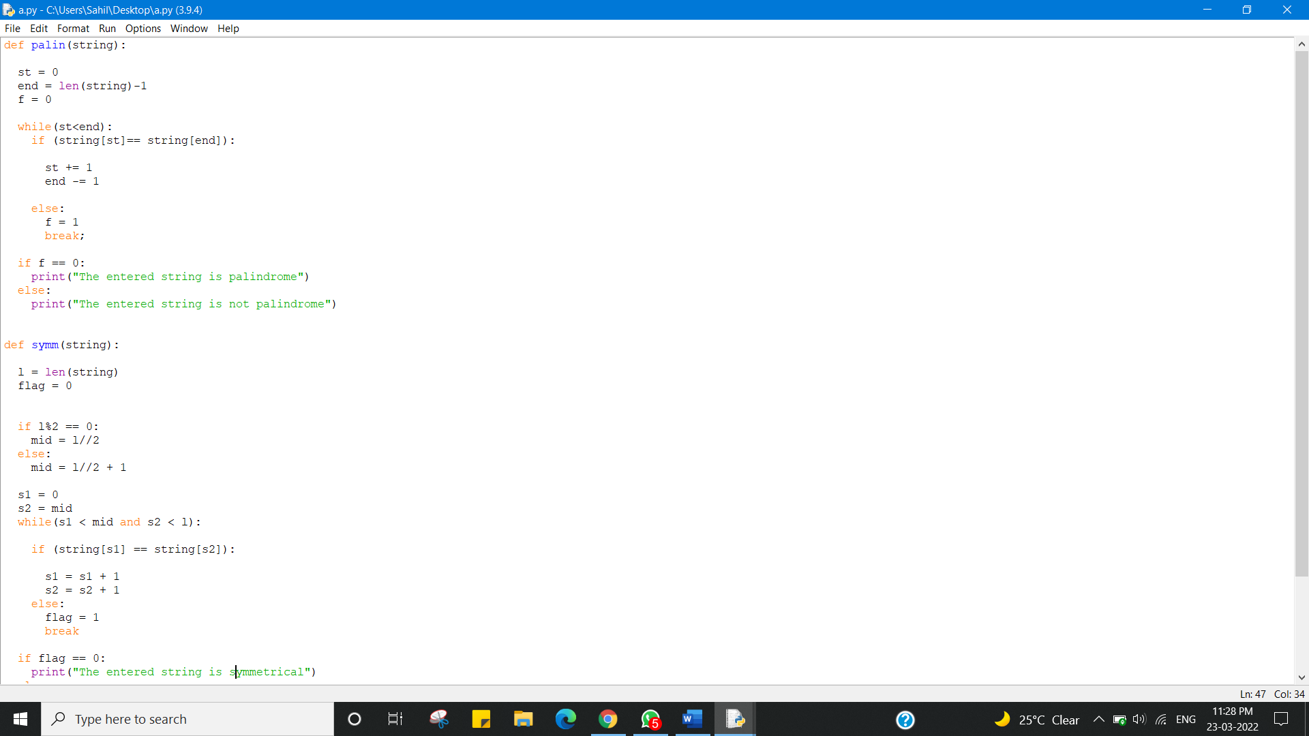

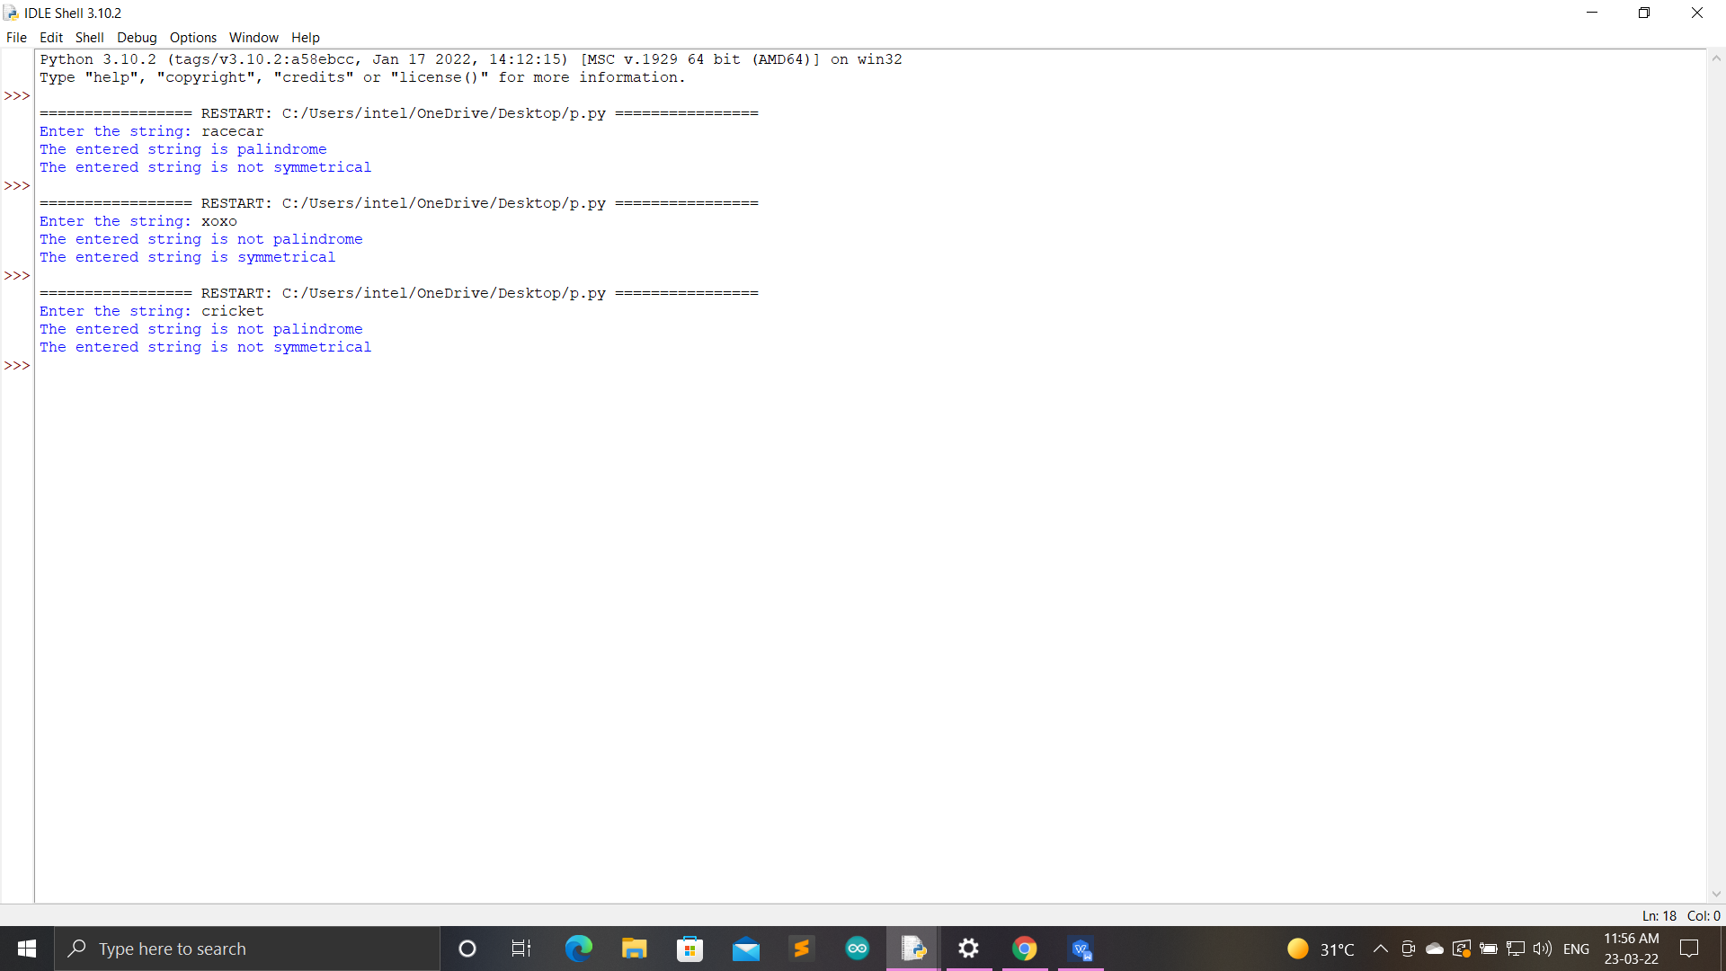

**Q2.**

1. **Aim:**

Python program to find uncommon words from two Strings

1. **Task:**

**To** find uncommon words from two Strings

1. **Coding:**

str1 = input('Enter first string : ')

str2 = input('Enter second string : ')

count = {}

for word in str1.split():

count[word] = count.get(word, 0) + 1

for word in str2.split():

count[word] = count.get(word, 0) + 1

uncommonWords = [word for word in count if count[word] == 1]

print("All uncommon words from both the string are ", uncommonWords)

1. **Output:**

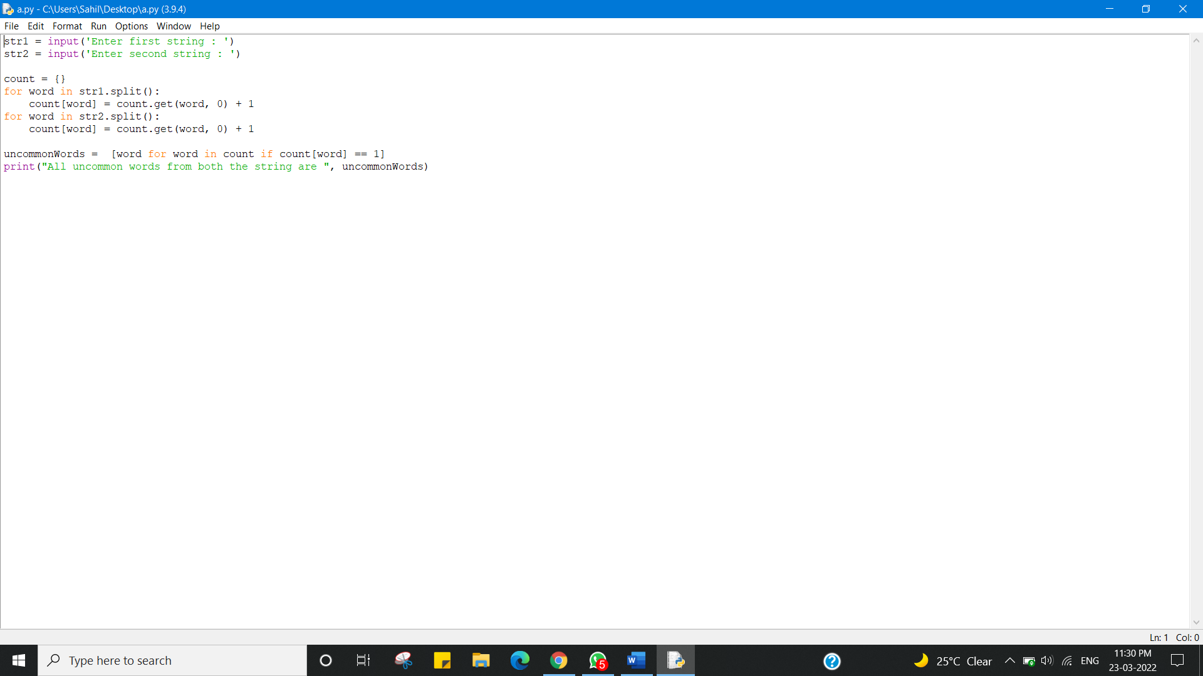

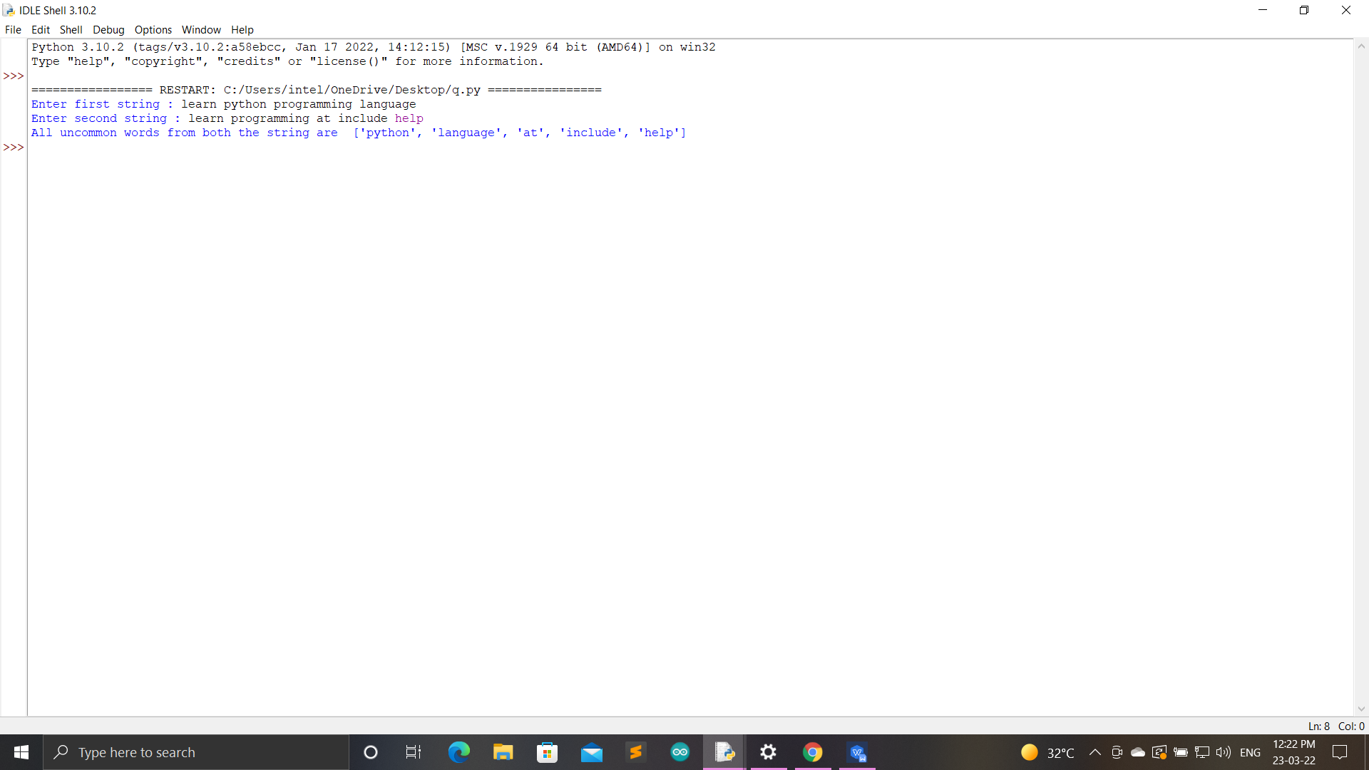

**Q3.**

1. **Aim:**
2. Write a Python program to add 'ing' at the end of a given string (length should be at least 3). If the given string already ends with 'ing' then add 'ly' instead. If the string length of the given string is less than 3, leave it unchanged. Example:- Sample String : 'abc' Expected Result : 'abcing' Sample String : 'string' Expected Result : 'stringly'
3. **Task:**
4. To add 'ing' at the end of a given string (length should be at least 3). If the given string already ends with 'ing' then add 'ly' instead. If the string length of the given string is less than 3, leave it unchanged. Example:- Sample String : 'abc' Expected Result : 'abcing' Sample String : 'string' Expected Result : 'stringly'
5. **Coding:**

def add_string(str1):

length = len(str1)

if length > 3:

if str1[-3:] == 'ing':

str1 += 'ly'

else:

str1 += 'ing'

return str1

print('String less than 3 - UNCHANGED:')

print(add_string('ab'))

print('\nAdd ing at last - + ing:')

print(add_string('abc'))

print('\nalready ending with ing - + ly:')

print(add_string('string'))

1. **Output:**

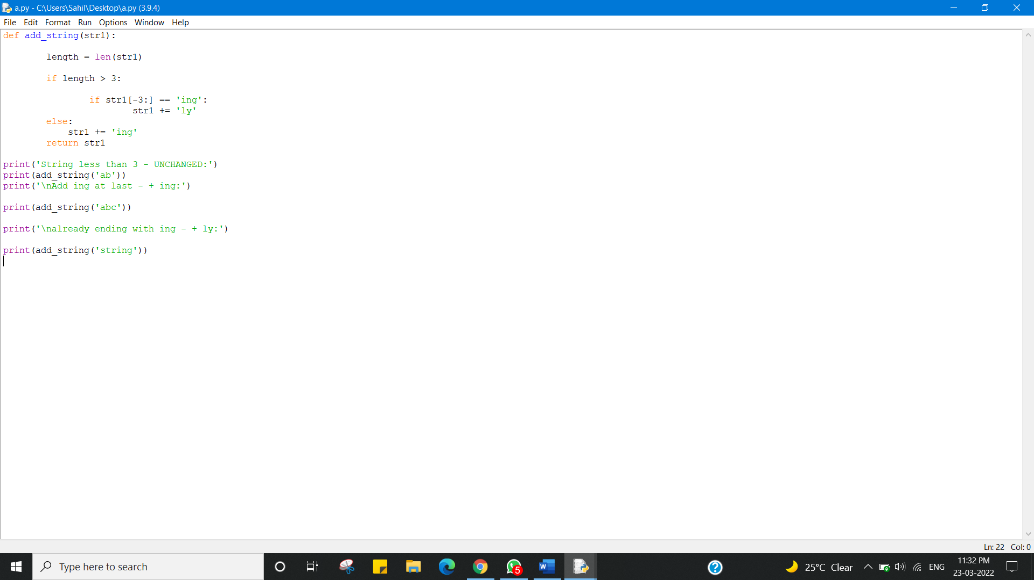

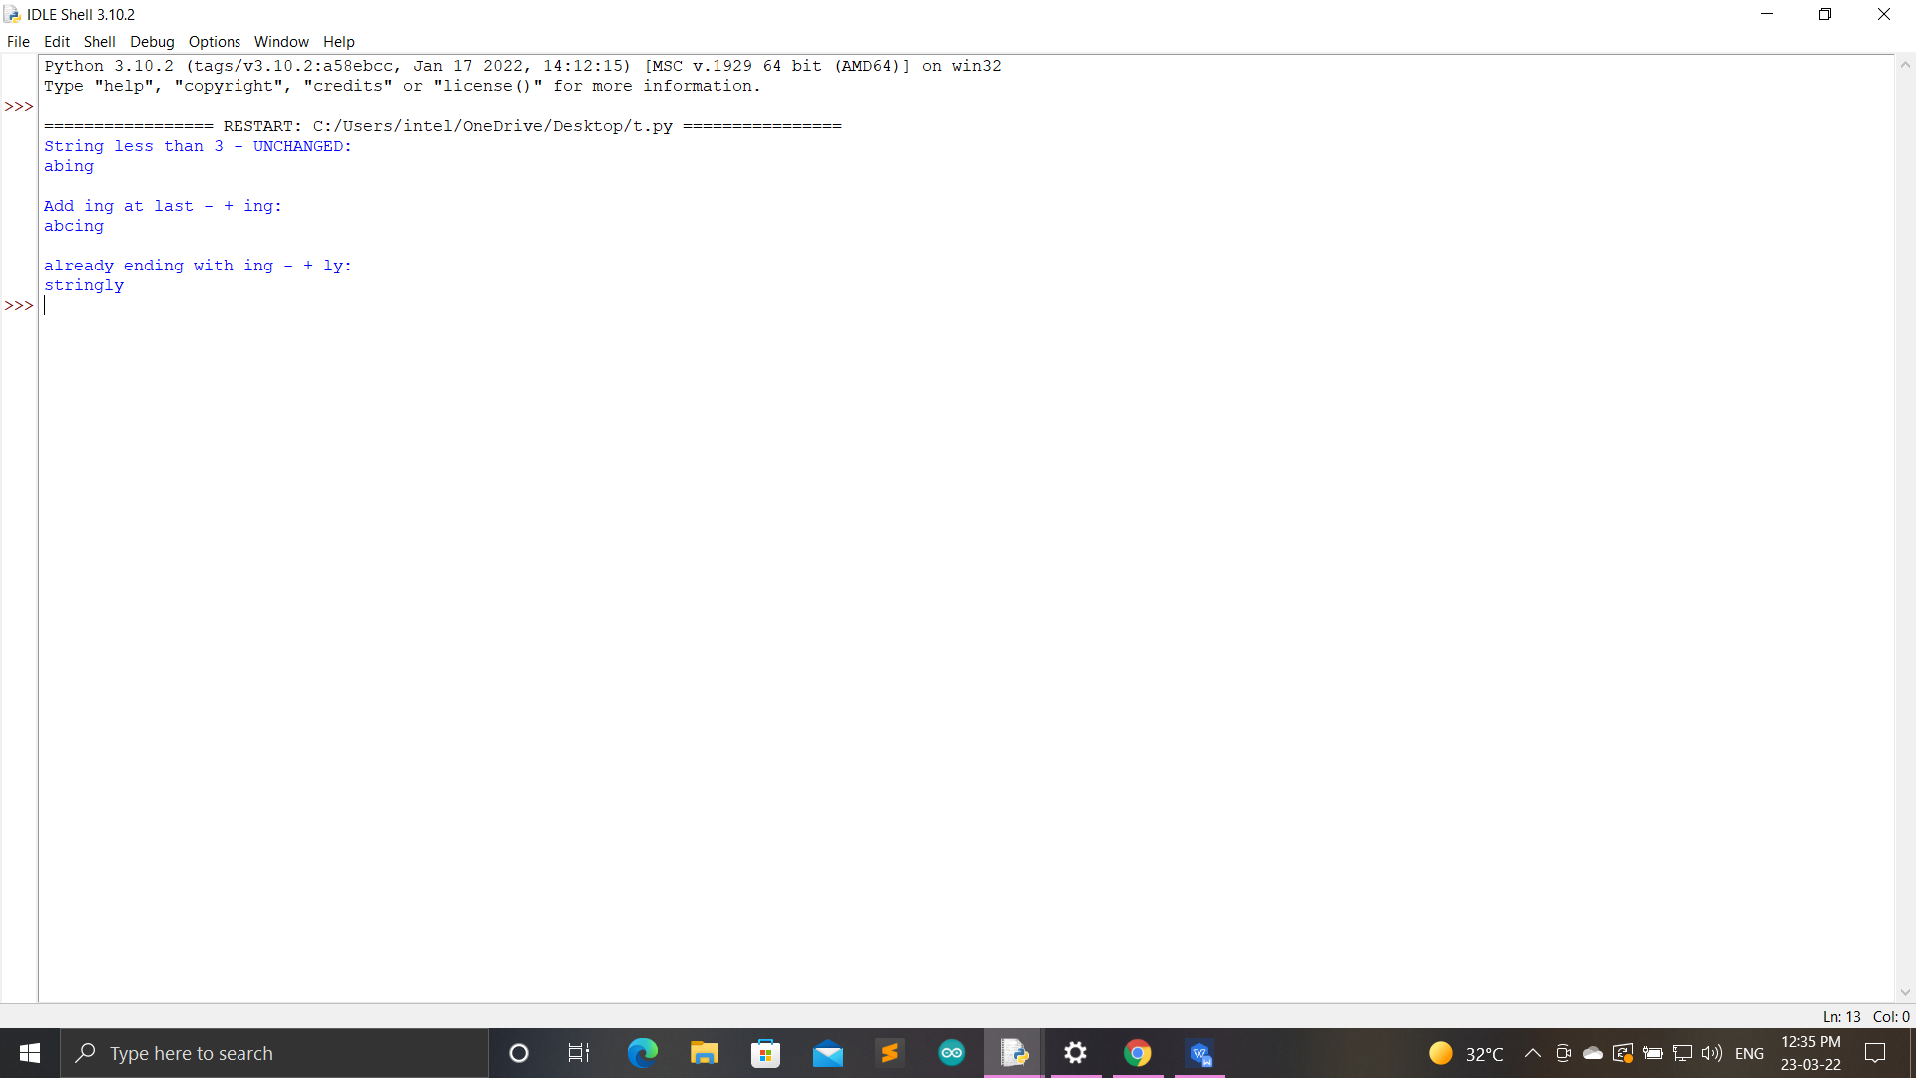

**Result:-**

I have successfully completed this experiment.

**Learning outcomes (What I have learnt):**

1. Python program to check whether the string is Symmetrical or Palindrome.
2. Python program to find uncommon words from two Strings
3. Python program to add 'ing' at the end of a given string (length should be at least 3). If the given string already ends with 'ing' then add 'ly' instead. If the string length of the given string is less than 3, leave it unchanged. Example:- Sample String : 'abc' Expected Result : 'abcing' Sample String : 'string' Expected Result : 'stringly'

Evaluation Grid (To be created as per the SOP and Assessment guidelines by the faculty):



|  |  |  |  |
| --- | --- | --- | --- |
| Sr. No. | Parameters | Marks Obtained | Maximum Marks |
| 1. |  |  |  |
| 2. |  |  |  |
| 3. |  |  |  |
|  |  |  |  |